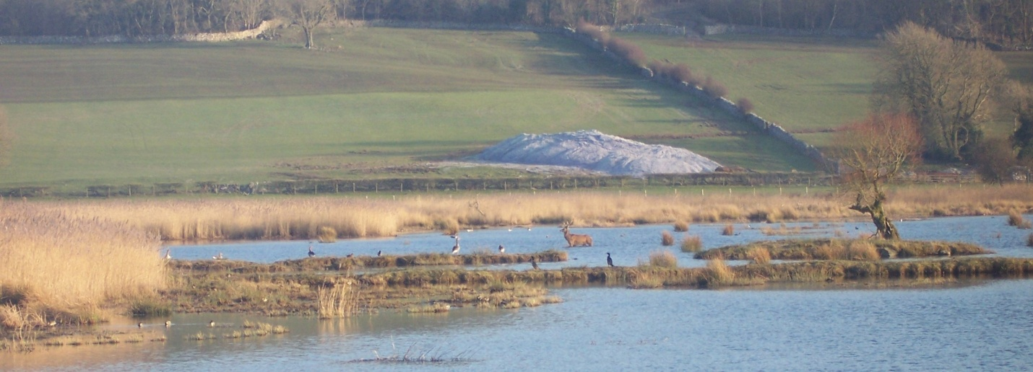

Catchment Restoration Fund Briefing Note

Key facts
River Basin District | North West
Catchments | South West Lakes (part), Duddon, Kent / Leven, Leighton Moss, Lune, and Wyre
Outcomes | Natural flow regimes - a reduction in peak and low flows.  Improved biodiversity - increased riverine habitat, connectivity and re-naturalisation, enhanced wetland and woodland habitats.  Improved river water quality - reduced diffuse pollution.  Improved bathing water quality - reduction in pathogens from rural sources, and reduced beach litter.  Social - improved environment for recreation, and greater public awareness of water quality issues.  Economic - improved inland fisheries and estuary shellfisheries.  Climate change mitigation - carbon sequestration and shading of watercourses.
Start Date | 01 July 2012
End Date | 31 March 2015
Budget | £1,173,574 from CRF
Project Partners | RSPB (lead)  Cumbria Wildlife Trust  Cumbria Woodlands  Lune Rivers Trust  Morecambe Bay Partnership  Arnside & Silverdale AONB  Partnership  South Cumbria Rivers Trust
Background
Society needs water for life. To provide this, we need to reduce pollution that comes from the way land is used and improve the landscape through which water flows.
Working through river basin management plans, the Water Framework Directive (WFD) requires that waters (including rivers, lakes, groundwaters, estuaries, and coastal waters) are managed sustainably. Good status for each type of water body is defined by a set of biological, chemical and physical standards. 26% of England’s water bodies are currently classified as being of ‘good status’ or 'potential' or better.
After a major programme of investigations at thousands of sites across England, the Environment Agency has started to understand why waters fail to achieve good status. This evidence is being used to target action and investment to protect and improve waters.
The Department for Environment, Food and Rural Affairs (Defra) has created the Catchment Restoration Fund, which is administered by the Environment Agency. The Catchment Restoration Fund (CRF) supports third sector groups to bring forward projects that will at a catchment level:
- restore natural features in and around watercourses;
- reduce the impact of man-made structures on wildlife in watercourses; and
- reduce the impact of diffuse pollution arising from rural and urban land use.
Source to Sea Programme
Morecambe Bay and its river catchments should be considered as one interacting entity. Therefore, the Source to Sea Programme is a pan-Morecambe Bay CRF initiative that encompasses restoration projects for a range of waterbodies, protected sites, and associated priority habitats and species.
The project will restore the natural connections along watercourses (removing barriers) and between watercourses and their floodplains and headwaters (restoring habitats).
The project works in partnership with landowners and managers to bring about land management change to benefit water quality and raises awareness amongst Morecambe Bay coastal communities.
Diffuse pollution, a lack of riparian habitat, unnatural flow regimes attributable to upland drainage and obstructions to fish passage are causing certain watercourses in the project area to fail to meet the required standards under the WFD. Fish populations, particularly salmonids, have been found to be greatly diminished.
To ensure that the failing waterbodies achieve Good Ecological Status under the WFD, the project aims to improve the habitat and connectivity in order to generate sustainable fish populations. The creation of wetland habitats and riparian buffer zones will reduce diffuse pollution from farmland and roads, and some upland drainage grips are to be blocked to encourage a sustainable return to natural flow regimes.
Through restoration work, the project will address issues including:
- Unnatural flow regimes caused by upland grips;
- Sediment which has a direct adverse effect on water quality;
- Barriers to fish migration, preventing fish from reaching habitat where they should be present;
- Interrupted natural downstream movement of substrate - reducing spawning habitat for salmonids and freshwater pearl mussel;
- Fertiliser runoff into waterbodies that can cause nutrient enrichment and impact negatively on their ecology;
- Expected rise in river water temperature associated with climate change; and
- Failed bathing water standard in coastal reaches due to presence of excess pathogens attributable to upstream sources, and accumulations of litter on the shore.

Description of works
SOURCE TO SEA PROJECT AREA
Through 11 projects led by partner organisations:
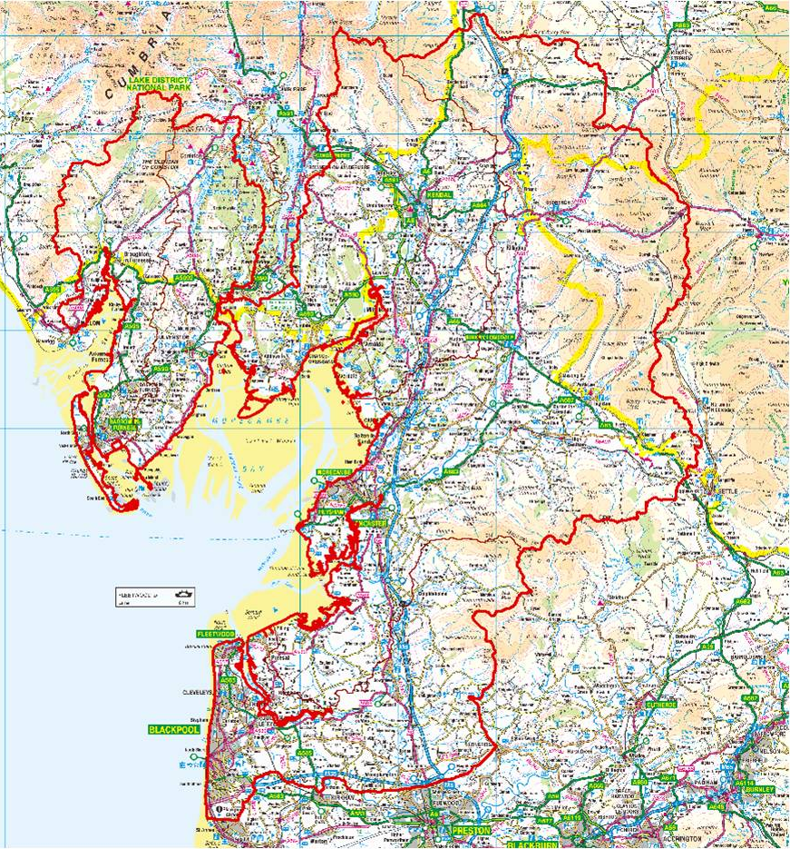
- Restoring natural hydrology - the presence of man-made grips on the moorland above the River Kent (Sprint and Mint) has resulted in changes to the hydrology of the catchment. The blocking of certain grips will help to restore natural flow regimes, reducing the frequency and intensity of peak flows and increasing baseline flows. It will also aid in reducing diffuse pollution. In the first instance, the project will survey and map the grips to prioritise which require blocking.
- Fencing - where agricultural practices are causing the watercourse to fail to meet WFD standards, riparian fencing and associated drinking points will result in multiple benefits. The poaching of riverbanks by livestock will be reduced, as will the associated excess sediment inputs. Vegetation will become re-established along the riverbanks, therefore increasing riparian habitat and biodiversity. This will result in the establishment of a buffer zone that will reduce the amount of nutrient run-off that enters the watercourse from farmland and roads. It will also aid in reducing pathogens in the water that may cause Bathing Water Directive failures in Morecambe Bay.
- Tree planting - where there is sufficient area between the fence and the watercourse, native trees will be planted to provide additional bank stabilisation and habitat. Once matured, the trees will also create shading over the watercourse and reduce the effects of the expected rise in water temperature attributable to climate change. If the planting area is sizeable (>0.25 ha) this could result in significant grant aid benefiting farmers/landowners.
- Wetland creation – by intercepting contaminated water before entering watercourses, sediments and pollutants can be settled out and improved quality water then discharged to receptor waters. These wetlands themselves help connect important habitats and also offer buffering to increased flooding and drought.
- Reconnecting habitat - where an obstruction to fish passage exists within the river channel, the project will look to remove it or make it passable. This will not only open up more habitat to migratory fish, but where removal occurs it will also return sediment movement to a more natural regime.
- Community engagement - as an integral part of integrated catchment management this is essential to the long-term success of the project. It encourages local ownership and support. Engagement activities will include public consultations, practical volunteering activities like beach cleans, and tree planting, and awareness-raising through media and face-to-face contact.
What will success look like?
- Work toward getting the waters that discharge into Morecambe Bay into Good Ecological Status, under the Water Framework Directive, through practical farm management solutions that benefit both people and the environment;
- Local people taking ownership of the issues affecting their watercourses, understanding their direct and indirect dependence on these natural resources and the services they provide;
- A reconnection of rivers, their habitats and their catchments through improved woodland and wetlands adjoining the watercourses;
- Greater biodiversity in and around the rivers; and
- Improvement of bathing water standards of Morecambe Bay and the North West coastal region.

Contacts summary table
About the Team
Project Manager | Richard Cooper (RSPB) | richard.cooper@rspb.org.uk | 01524 581010
Admin, Finance | Nicky Kurc (RSPB) | Regional Director | Peter Robertson
Other Contacts
E.A. local officer | Simon Bennett (S) / Natalie Bibby (N) | Lune Rivers Trust | Sarah Littlefield
Cumbria Wildlife Trust | Simon Thomas | Cumbria Woodlands | Neville Elstone
Morecambe Bay Partnership | Emma McColm | Arnside & Silverdale AONB | Lucy Barron
South Cumbria Rivers Trust | Peter Evoy | RSPB | Robin Horner

